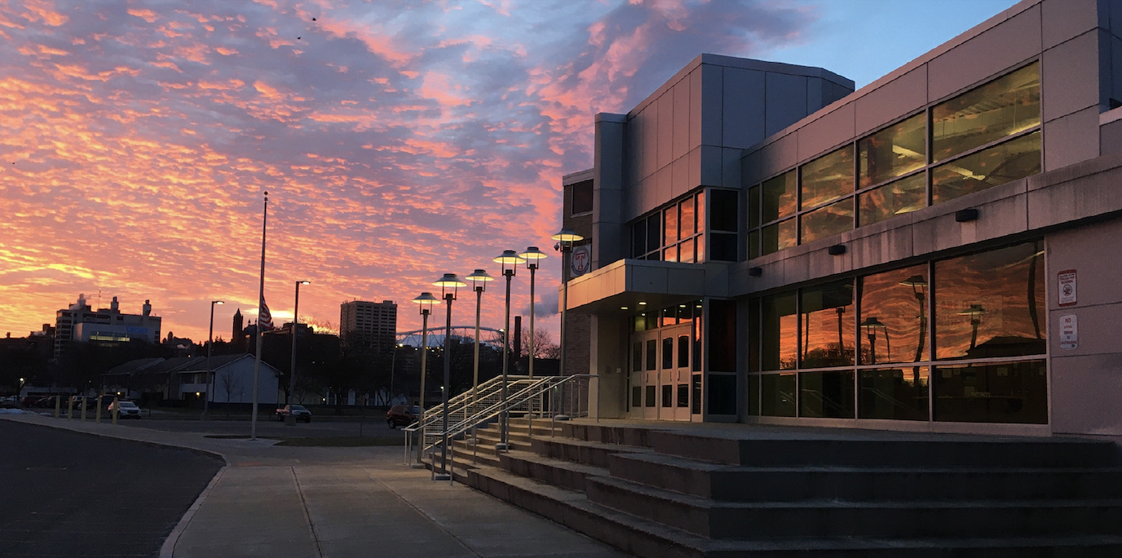

MINIMUM CAPACITY :-

The Minumum intake capacity

of students is between 700-920

children

LIBRARY :-

The Libarary is Available.

CANTEEN:-

The Canteen Facility is Available.

BOARDING :-

No availablility of boarding.

SPORTS :-

There are different categories

sports available.

Girls Volleyball

Boys Volleyball

Football

|  |  |  |
| --- | --- | --- |
| INSTITUTE OF TECHNOLOGY AT SYRACUSE CENTRAL SYRACUSE - SCHOOL |  |  |
|  |  |  |
| School Detail :- The Institute of Technology at Syracuse Central, is a high school in downtown Syracuse, New York. Central Tech opened during the 2007–2008 school year, with 96 students in their freshman year.  ITC re-opened in a newer building *next to* historic Central, at 258 East Adams Street, for the 2007–2008 school year. After the 2009–2010 school year, renovations began. During the 2010–2012 school years, students attended T. Aaron Levy Levy Middle School (closed in 2012). The renovations included a new gym, scheduled for completion by Thanksgiving 2012. At the beginning of the 2012–2013 school year, students and teachers returned to the renovated building, where they currently attend classes. |  |
|